5.1 Data Collection
The first step involves collecting both normal and malicious network traffic data from reliable sources. The dataset consists of labelled network traffic samples that represent various types of DDoS attacks.
Data Sources:
- Standard benchmark datasets such as CICIDS2017 by Ameur Salem

5.2 Data Preprocessing
Raw network traffic data is noisy and inconsistent. Therefore, preprocessing is performed to improve data quality.
Key preprocessing steps:
- Removal of duplicate and corrupted records
- Handling of missing values using statistical imputation
- Label encoding of categorical attributes
- Normalization and standardization of numerical features using Min-Max Scaling or Z-score normalization
- Balancing of data using oversampling (SMOTE) or undersampling to reduce class imbalance
This ensures the dataset is clean, consistent, and suitable for model training.

5.3 Feature Engineering
Feature engineering is a critical step in the DDoS attack detection system, as it transforms raw network traffic data into meaningful representations suitable for different types of models. Separate feature engineering pipelines are designed for traditional machine learning (ML) models and deep learning (DL) models.

4.4 Model Design and Training
Machine Learning using XGBoost
The machine learning module of the proposed DDoS detection system is designed using the XGBoost (Extreme Gradient Boosting) algorithm due to its high efficiency and strong performance on structured network traffic data. XGBoost is an ensemble learning technique that combines multiple weak decision tree classifiers to form a strong predictive model. Each successive tree is trained to correct the errors made by previous trees, thereby improving overall accuracy. This iterative boosting mechanism makes XGBoost particularly effective in handling complex patterns in network traffic.
In this project, a set of carefully selected network traffic features is used as input to the XGBoost model. These features include packet count, packet rate, flow duration, packet length statistics, protocol type, and port information, which are known to be significant indicators of DDoS attacks. Prior to model training, the dataset undergoes preprocessing steps such as removal of irrelevant attributes, handling of missing values, and feature scaling using standard normalization techniques. Feature scaling ensures that all input features contribute proportionately to the learning process.
The preprocessed dataset is divided into training and testing subsets to evaluate the model’s generalization capability. During training, important hyperparameters such as learning rate, maximum tree depth, and number of estimators are tuned to achieve optimal performance while avoiding overfitting. The objective function used by XGBoost minimizes classification error by applying gradient descent optimization. The trained model is evaluated using metrics such as accuracy, precision, recall, and F1-score to measure its effectiveness in distinguishing between normal and attack traffic.
Pseudo code: XGBoost for DDoS Attack Detection
BEGIN
Step 1: Load the network traffic dataset
Step 2: Perform data preprocessing
Step 3: Split the dataset into training data and testing data
Step 4: Initialize XGBoost parameters
- Learning rate
- Maximum tree depth
- Number of boosting iterations
Step 5: Initialize the model with a base prediction
Step 6: For each boosting iteration
- Calculate prediction errors (residuals)
- Compute gradients of the loss function
- Train a decision tree using gradients
- Add the new tree to the existing model
Step 7: Repeat Step 6 until all trees are trained
Step 8: Evaluate the trained model using test data
Step 9: Calculate performance metrics
Step 10: Save the trained XGBoost model and scaler
Step 11: Use the saved model to classify live network traffic
as Normal or DDoS Attack
END

Once satisfactory performance is achieved, the trained XGBoost model and the associated feature scaler are saved using Joblib. These saved artifacts are later loaded during the live traffic prediction phase, ensuring consistency between training and inference. The XGBoost model provides fast prediction speed and low computational overhead, making it suitable for real-time DDoS detection scenarios.
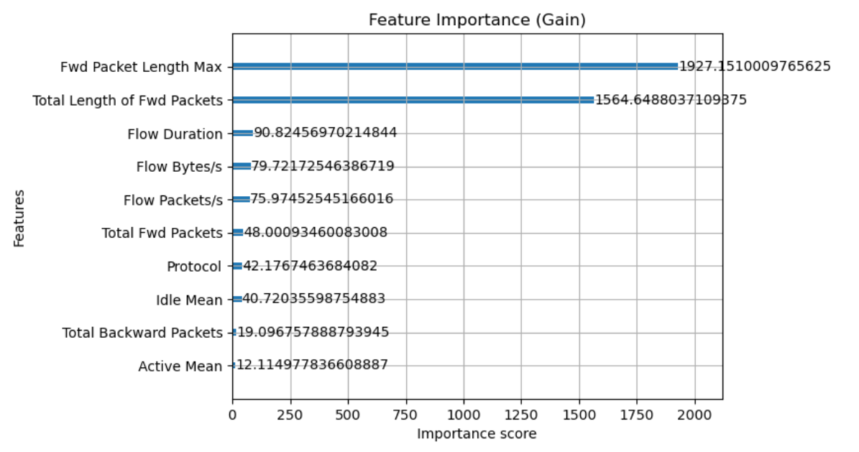
Fig. 4.4.1 Feature Importance for XGBoost

Deep Learning using Deep Neural Network (DNN)
The deep learning component of the proposed system employs a Deep Neural Network (DNN) to identify complex and non-linear patterns in network traffic that may indicate sophisticated DDoS attacks. Unlike traditional machine learning models, DNNs are capable of learning hierarchical feature representations, making them well-suited for detecting subtle and evolving attack behaviors.
The DNN architecture designed in this project consists of an input layer, multiple hidden layers, and an output layer. The input layer receives normalized network traffic features identical to those used in the machine learning module, ensuring uniformity across the detection framework. The hidden layers are fully connected and utilize the Rectified Linear Unit (ReLU) activation function, which enables efficient learning and faster convergence. To prevent overfitting, dropout layers are introduced between hidden layers by randomly disabling a fraction of neurons during training.
The output layer uses a sigmoid activation function to perform binary classification, producing a probability score indicating whether the observed traffic is normal or malicious. The model is trained using the binary cross-entropy loss function, which is suitable for binary classification tasks. The Adam optimizer is employed to adaptively adjust learning rates and accelerate convergence. Early stopping is applied during training to monitor validation loss and prevent overtraining.
The training dataset is split into training and validation sets to assess model performance during learning. After training, the DNN model achieves improved detection accuracy for complex DDoS patterns compared to traditional classifiers. The trained model is saved in serialized format and loaded during live traffic analysis using real-time packet capture modules. This ensures that the model operates efficiently during deployment without retraining.
Pseudo code: Deep Neural Network for DDoS Attack Detection
BEGIN
Step 1: Load the network traffic dataset
Step 2: Perform data preprocessing
Step 3: Split the dataset into training data and testing data
Step 4: Initialize Deep Neural Network
- Input Layer
- One or more hidden layers
- Output Layer
- Initialize weights and biases

Step 5: For each training epoch
- Perform forward propagation
- Compute predicted output
- Calculate loss using binary cross entropy
- Perform backpropagation
- Update weights using Adam optimizer
Step 6: Repeat Step 5 until convergence or early stopping
Step 8: Evaluate the trained model using test data
Step 9: Calculate performance metrics
Step 10: Save the trained DNN model and scaler
Step 11: Use the saved model to classify live network traffic
as Normal or DDoS Attack
END

5.5 Model Evaluation
Model evaluation is a critical phase in the proposed DDoS attack detection system, as it determines the effectiveness and reliability of both machine learning and deep learning models in distinguishing normal network traffic from attack traffic. The evaluation process is carried out after model training to assess how well the models generalize to unseen data. In this project, both the XGBoost-based machine learning model and the Deep Neural Network (DNN) model are evaluated using standard performance metrics commonly used in binary classification problems.
The dataset is divided into training and testing sets to ensure unbiased evaluation. The trained models are tested on the unseen test dataset, and predictions are compared with actual labels to measure classification performance. Key evaluation metrics include accuracy, precision, recall, and F1-score. Accuracy measures the overall correctness of predictions, while precision indicates the proportion of correctly identified attack instances among all predicted attacks. Recall measures the ability of the model to correctly detect actual attack traffic, which is especially important in security applications. The F1-score provides a balanced measure by combining precision and recall.
In addition to these metrics, confusion matrices are used to analyze the classification results in terms of true positives, true negatives, false positives, and false negatives. This analysis helps in understanding the types of errors made by the model and their potential impact on real-time detection. A low false negative rate is particularly desirable, as undetected DDoS attacks can severely affect network availability.
For the deep learning model, validation loss and validation accuracy are monitored during training to prevent overfitting. Early stopping techniques are applied when the validation performance stops improving. The machine learning model is evaluated for both accuracy and prediction speed, as fast inference is essential for live traffic monitoring. The evaluation results indicate that the DNN model achieves higher accuracy for complex attack patterns, while the XGBoost model provides faster and more efficient predictions.
Overall, the evaluation results demonstrate that the proposed system achieves reliable and accurate DDoS detection. The combination of quantitative metrics and error analysis confirms the suitability of the models for real-time deployment in network security environments.
Model performance is evaluated using standard classification metrics:
- Accuracy
- Precision
- Recall
- F1-Score
Comparative analysis is performed between machine learning and deep learning models to select the most robust model.

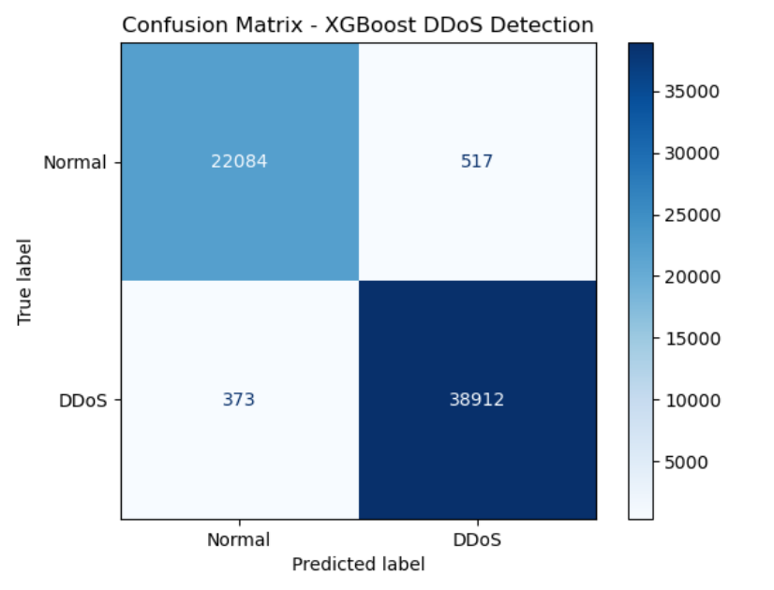
Fig 5.5.1 Confusion matrix for machine learning model

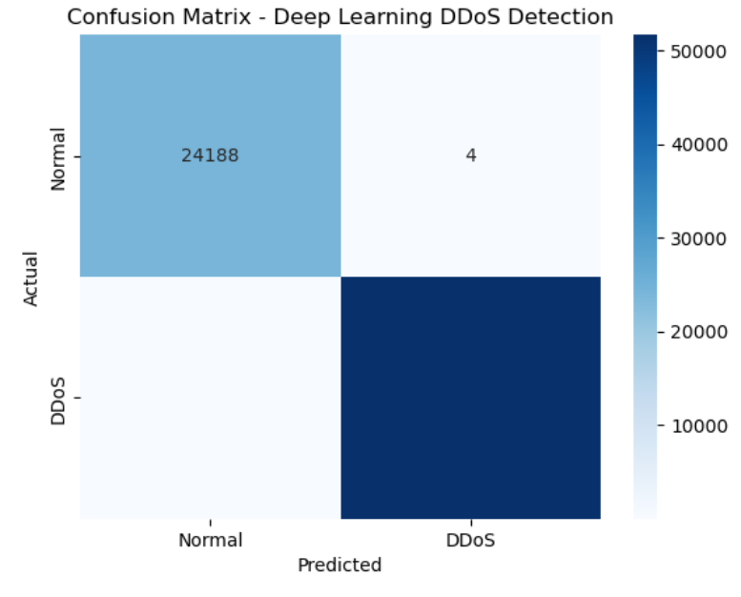
Fig 5.5.2 Confusion matrix for deep learning model
Shri B.V.V. Sangha’s
BASAVESHWAR ENGINEERING COLLEGE, BAGALKOTE
[AICTE Approved, Government Aided Institution Affiliated To VTU, Belagavi]

DEPARTMENT OF COMPUTER SCIENCE & ENGINEERING

Major-Project Report on
“Distributed Denial of Service (DDoS) Attack Detection”
Submitted in partial fulfillment of requirement for the award of the degree
BACHELOR OF ENGINEERING
In
COMPUTER SCIENCE AND ENGINEERING
2025-2026

Project Guide Coordinator HOD
Prof. Smitha K Dr. Vilas Naik Dr.V.B. Pagi

Submitted by:
Aditi Rudrakshi
Amruta Viraktamath
Anandkumar Bhairamatti
Bharathkumar Kharoshi
2BA22CS005
2BA22CS013
2BA22CS014
2BA22CS020



Shri B.V.V. Sangha’s
BASAVESHWAR ENGINEERING COLLEGE, BAGALKOTE
[AICTE Approved, Government Aided Institution Affiliated To VTU, Belagavi]

Department of Computer Science and Engineering

CERTIFICATE

This is to certify that Aditi Rudrakshi(2BA22CS005), Amruta Viraktamath(2BA22CS013), Anandkumar Bhairamatti(2BA22CS014), Bharath Kumar Kharoshi(2BA22CS020) has satisfactorily completed the mini-project on “Distributed Denial of Service (DDoS) Attack Detection”, for partial fulfillment of their course in B.E. Computer Science and Engineering prescribed by Basaveshwar Engineering College, Bagalkote during the academic year 2025-2026.

Project Guide Coordinator HOD
Prof. Smitha K Dr. Vilas Naik Dr.V.B. Pagi

Name of Examiners Signature of Examiner
1…………………… 1………………………
2………………….... 2………………………
3………………….... 3………………………
CONTENTS
Chapter 1 |  |  | Introduction
1.1 |  |  | Background
 |  | 1.1.1 | Evolution of online services
 |  | 1.1.2 | Rise of cyber threats in modern networks
 |  | 1.1.3 | Emergence of distributed attacks
1.2 |  |  | Understanding DDoS Attacks
 |  | 1.2.1 | Definition and concept
 |  | 1.2.2 | Types of DDoS Attacks
1.3 |  |  | Challenges in detecting DDoS attacks
1.4 |  |  | Problem Statement
1.5 |  |  | Objectives
Chapter -2 |  |  | Literature survey
Chapter -3 |  |  | System Requirements
3.1 |  |  | Hardware Requirements
3.2 |  |  | Software Requirements
 |  | 3.2.1 | Operating System
 |  | 3.2.2 | Developmental Environment
 |  | 3.2.3 | Libraries and Framework
3.3 |  |  | Network Requirements
3.4 |  |  | Dataset Requirements
3.5 |  |  | Non- Functional Requirements
Chapter -4 |  |  | Proposed Methodology
4.1 |  |  | Overview of Proposed Methodology
4.2 |  |  | System architecture
Chapter -5 |  |  | System Implementation
5.1 |  |  | Data collection
5.2 |  |  | Data Preprocessing
5.3 |  |  | Feature Engineering
5.4 |  |  | Model Design and Training
5.5 |  |  | Model Evaluation
Chapter -6 |  |  | Validation and Results
6.1 |  |  | Dashboard based validation
6.2 |  |  | Live traffic capture testing
6.3 |  |  | Local testing and trigger-based evaluation
 |  |  | Conclusion
 |  |  | References

List of Figures

Figure No. | Caption | Page No.
4.2.1 | System Architecture
5.4.1 | Feature Importance for XGBoost
5.5.1 | Confusion matrix for machine learning model
5.5.2 | Confusion matrix for deep learning model
5.5.3 | Accuracy comparison
6.1.1 | Dashboard Interface
6.1.2 | Offline Testing Results Displayed on Dashboard for XGBoost
6.1.3 | Offline Testing Results Displayed on Dashboard for XGBoost
6.1.4 | Offline Testing Results Displayed on Dashboard for DNN
6.1.5 | Offline Testing Results Displayed on Dashboard for DNN
6.2.1 | Real Time Normal Traffic Detection Output using XGBoost model
6.2.2 | Real Time DDoS Attack Detection Output using Deep Neural Network model
6.6.3 | Trigger Based Detection Control for XGBoost Model
6.6.4 | Trigger Based Detection Control for DNN Model

